Object Detection for Robot Arm Control using Computer Vision



|  |  |
| --- | --- |
| Submitted by: | Maria Majid - 1324374  Sidra Hussain - 1318131 |
| Examiner: | Prof. Peter Nauth |
|  |  |
| Course: | Autonoumous Intellegent System WS 20/21 |
| Date of submission: | 14th May, 2021 |

Content

Abstract 3

1 Introduction 4

2 Theoretical Background 5

2.1 Theoretical Background 5

2.1.1 Heading 5

2.2 Figures 5

2.2.1 Self-created Figures/Drawings 6

2.2.2 Screenshots 6

2.3 Tables 6

2.4 Tips for Numbering of Figures and Tables 7

2.5 Mathematical Formulas 8

2.6 Source Code 8

2.7 The Size of Bachelor and Master Thesis 8

2.8 Literature and References 8

3 Requirements Analysis 11

3.1 General Objectives 11

3.2 Clarifying the Requirements 11

3.3 Time frames 12

3.4 Target state / Target Objectives 12

3.5 Use Cases for the Prototype 13

4 Realisation / Implementation 15

5 Summary and Perspectives 16

6 Abbreviations 17

7 References 18

8 Appendix 19

# Abstract

Object detection is a key enabling feature that is extensively used in computer and robotic vision systems. Object detection intends to distinguish between various object instances in the targeted scenario and categorize those objects with labels and position information. Due to various human and natural influences affecting the environment, the task of detection and identification of different objects is considered highly challenging. A numerous amount of successful research in the topics of object detection and identification using computer vision and machine learning techniques is observed during the last course of years. The amalgamation of computer vision and deep learning for object detection stands out as the most efficient and successful technique so far. In this project, a similar approach is used to perform object detection and differentiation using computer vision and deep learning techniques to serve the Robot Arm Control. This project enables the Robot’s ability to identify the targeted object instance in the given scenario to perform further actions as per the given command. The proposed solution utilizes the deep learning based Single Shot multi-box Detector (SSD) framework along with the Mobilenet, large Common Object in Context (COCO) dataset and OpenCV library to perform object detection tasks for Robot Arm Control. The Non-Maximum Suppression (NMS) algorithm is applied on the detected object instances to achieve filtered and accurate output. An in-depth model evaluation report is also provided to scrutinize the performance and efficiency of the proposed solution.

# Introduction

Welcome to your thesis in the Laboratory for Telecommunications Networks of Frankfurt University of Applied Sciences! This Word document contains some information for your thesis and also serves as a template for dealing with headlines and highlights, the titling of images and tables as well as for the use of abbreviations and references.

Scientific texts are basically never written in first person ("I have chosen the program XY ...", "In my thesis ..."). Better is: "The program XY has been chosen...", "In this thesis ..." etc.

The use of the imperative or the second person ("Push the button ...") is limited to specific instructions in the chapter Realisation.

The names of the main chapters in the table of contents are always the same (see table of contents). The chapters are named as followed:

1. Introduction

2. Theoretical Background

3. Requirements Analysis

4. Realisation

5. Summary and Future Perspectives

6. Abbreviations

7. References

**Note:** This paragraph is followed by a section change, which should not be deleted. It allows for a clean separation of chapters. More information about section breaks below. Press <CTRL>+<SHIFT>+<PLUS> to show or hide invisible control characters and thus the section break.

# Theoretical Background

Each chapter (= chapter heading of the first order) starts on a new page. Each chapter begins with a new number (e.g. 2 Theoretical Background). All others are sections (e.g. 2.1 or 2.1.1).

The theoretical background and the required technologies are content of this chapter. It is not allowed that the theoretical background of a topic is copied-and- pasted from other sources. **Only the parts that are relevant for this work, have been specially adapted by the student and are therefore not found in other sources in this form, are described in this chapter.** For a general description of a technology it is sufficient to cite the relevant source.

**Note:** On the View tab, under Show/Hide, click Navigation Pane. The structure of your document is then displayed on the left-hand side. Very helpful for jumping quickly from heading to heading in the document.

## Theoretical Background

### Heading

#### ****Heading third order****

Please use only headlines up to the third order. Therefore, only headlines up to third level are represented in the table of contents. It is recommended to use the default Word formats for headers. This will simplify the creation of the table of contents enormously.

This is standard text. Highlighting can be made **bold**, italics or alternatively, by underlining. However, accentua-tions should generally be used sparingly. Standard text has to be written in justified print, font Times, font size 10.

* Font: (Default) Times, Justified
* Line spacing: At least 12 pt, Space
* After: 7 pt, Widow/Orphan control

## Figures

A **figure** is always provided with a **caption** underneath with a short but precise description of the figure. The caption is written in italics and begins with the word “Figure”, followed by a number. This is created based on the number of the current main chapter heading and, separated by a dot, a sequential number in the current main chapter (see caption to Figure 2.1).

Each figure must be mentioned and explained in the text. The figure must be mentioned first in the text above the picture.

This is how you label an image:

1. click on the right side of the picture and go to "Insert Caption“.
2. Click on OK.
3. Label your image.

**Note:** Make sure that the content of the image is always clearly visible. Blurring and too small details should be avoided.

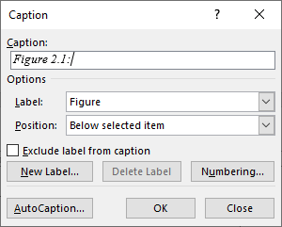

Figure 2.1: Insert a Caption

### Self-created Figures/Drawings

It is recommended to create figures and drawings for the thesis with MS PowerPoint or MS Visio. Store the figures created by PowerPoint or Visio in the appropriate format and in a safe place! Normally, do not copy and paste figures only e.g. to describe a software installation procedure with screenshots. Figures just copied from other publications are not accepted.

### Screenshots

Creating screenshots in Windows is pretty simple. With the key combination <Alt> + <Print> the active window can be captured. Thereafter, the image is available in the clipboard and can be added, edited and stored in any conventional image editing programs (e.g. Paint). Afterwards the picture can be inserted into Word.

In some cases, it may be useful to capture the contents of the entire screen (not just a single window). Press the <Print> key and then paste the image into an image editing program.

Advantageously also the Snipping Tool could be used.

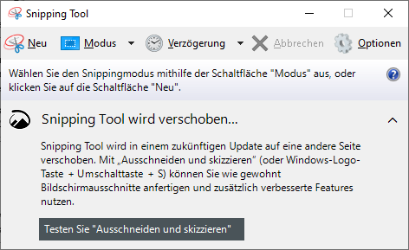

Figure 2.2: Snipping Tool

## Tables

Unlike figures, **tables** have no captions but a **headline**. The numbering of tables is performed according to the same principle as the numbering of figures. However, the numbering of figures and tables are independent of one another. There can be a Figure 2.1 as well as a Table 2.1 (see headline of Table 2.1).

Table 2.1: General Structure of a Master or Bachelor thesis

|  |  |
| --- | --- |
| **Chapter number** | **Chapter name** |
| 1 | Scope of work |
| 2 | Theoretical background |
| 3 | Requirement analysis |
| 4 | Realisation |
| 5 | Summary and future prospective |
| 6 | Abbreviations |
| 7 | References |

How to label a table:

1. mark the complete table, right click and go to "Insert Caption“.
2. click on OK.
3. Label your table.

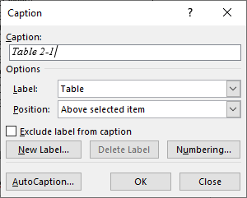

Bild 2.2: Table Caption

## Tips for Numbering of Figures and Tables

Word provides functionality for the automatic numbering of figures and tables. This can avoid issues with the numbering of figures and tables, which are subsequently inserted into the current text or removed from the cur-rent text. It is also possible to use table numbers or figure numbers in the text as a link. In this case, the number-ing of figures or tables changes automatically when changing the number of captions or the table heading. Use the Word Help for more information.

## Mathematical Formulas

You can even create formulas with Word. With <Alt> + <Shift> + <*> you call the formula editor.

$$a=\sqrt[3]{\frac{∂y}{∂x}}$$

## Source Code

Source texts should always be well formatted. Consider line breaks, indents and readability of the source code. Sometimes it can also be helpful to number the lines to make the reference in the text easier.

|  |  |
| --- | --- |
| 1 | package java.beans; |
| 2 |  |
| 3 | /** |
| 4 | * A "PropertyChange" event gets fired whenever a bean changes a "bound" |
| 5 | * property. You can register a PropertyChangeListener with a source |
| 6 | * bean so as to be notified of any bound property updates. |
| 7 | */ |
| 8 |  |
| 9 | public interface PropertyChangeListener extends java.util.EventListener { |
| 10 |  |
| 11 | /** |
| 12 | * This method gets called when a bound property is changed. |
| 13 | * @param evt A PropertyChangeEvent object describing the event source |
| 14 | * and the property that has changed. |
| 15 | */ |
| 16 |  |
| 17 | void propertyChange(PropertyChangeEvent evt); |
| 18 |  |
| 19 | } |

## The Size of Bachelor and Master Thesis

The required minimum size of a thesis depends on the type of the thesis. A bachelor thesis should target a mini-mum size of 40 pages and a master thesis a minimum size of 80 pages, each without appendix.

## Literature and References

For the references in bachelor or master theses the so-called Harvard style is used (Bahr and Frackmann, 2011; Pear and Shields, 2008; University of Plymouth, 2015). In Harvard style, the information is declared in the fol-lowing order:

* Creator/author
* Year of publication
* Title of information
* Tracing information

References within the text include paraphrasing as well as making direct quotations. You need to note the author’s surname, followed by the year of publication (Bloggs, 2006) and, for a direct quotation, the page number e.g. (Bloggs, 2006: 12). Additional examples: (IETF RFC 5022, 2007), (3GPP TS 23.228, 2006).

Where you are citing more than one work published by an author in one year you add a lower-case letter after the year e.g. (Bloggs, 2006a).

If two authors are stated in the publication, give the surnames of both authors e.g. (Bloggs and Smith, 2006).

If there are three or more authors, give the surname of the first followed by et al e.g. (Bloggs et al, 2006).

If two or more authors have the same surname the first letter from the first name is added to the reference: e. g. (Badach, A., 2015: 19) respectively (Badach, H., 2004: 34).

The full details of sources are given in the list of references at the end. In the list of references all sources are listed in alphabetical order, sorted by the name of the authors.

Book:

1. Surname and initials of author(s)
2. Year of publication (in brackets):
3. Title of book (in italics),
4. Edition (omit if first edition),
5. Place of publication:
6. Publisher.

E.g.

Clark, A. and Moss, P. (2001): Listening to young children: the Mosaic Approach, London: National Children’s Bureau.

Cohen, L., Manion, L. and Morrison, K. (2007): Research methods in education, 6th ed, London: Routledge.

If you have accessed a book or report on-line (on the WWW), you should reference it as a book but add further details to assist in tracing.

E.g.

Department for Education and Skills (2006): The five year strategy for children and learners: maintaining the excellent progress, London: DFES [online]

http://www.dfes.gov.uk/publications/5yearstrategyprogress/index.shtml [accessed 12 January 2007].

Article in journal or newspaper

1. Surname and initials of author(s)
2. Year of publication (in brackets):
3. Title of article,
4. Title of journal/newspaper (in italics),
5. Volume number
6. Part number (in brackets),
7. Page number(s).

E.g.

Hall, K. (2001): An analysis of primary literary policy in England using Barthes’ notion of 'readerly' and 'writer-ly' texts, Journal of Early Childhood Literacy, vol 1(pt 2), pp 153-165.

Sheehy, K. (2005): Morphing images: a potential tool for teaching word recognition to children with severe learn-ing difficulties, British Journal of Educational Technology, vol 36(pt 2), pp 293-301.

Lehmann, A. et al (2008): NGN und Mehrwertdienste – Geschäftsmodelle und Szenarien, NTZ, 01/2008, vol 61(pt 1), pp 22-25.

RFC Standard

1. Author
2. Year of publication (in brackets):
3. Title of RFC (in italics),
4. Publisher.

E.g.

IETF RFC 5022 (2007): Media Server Control Markup Language (MSCML) and Protocol, IETF

3GPP TS 23.228 V5.15.0 (2006), Technical Specification, “IP Multimedia Subsystem (IMS); Stage 2 (Release 5)”, 3GPP

Article in Electronic Journal or Newspaper

1. Author
2. Year of publication (in brackets):
3. Title of article,
4. Title of journal or newspaper (in italics),
5. Volume, part of journal (or publication date of newspaper)
6. Type of medium (in square brackets),
7. Location of document (full web address)
8. Access date (in square brackets).

E.g.

Claxton, G. (2007): Expanding young people’s capacity to learn, British Journal of Educational Studies, vol 55 (pt 2), pp 115-134, [online] Available at www.blackwellsynergy.com [accessed 16 July 2007].

Anderson, B. (2002): September 11 has turned out to be a good thing for America and the world, The Independ-ent, 9 September 2002, [online] Available at http://www.infoweb.newsbank.com/ [accessed 12 September 2002].

World Wide Web Document or page

1. Author or editor (if known, use name of website if all else fails)
2. Year of publication or last update:
3. Title of document or site or page (in italics),
4. Location of document (full web address)
5. Access date (in square brackets).

E.g.

Elder, L. and Paul, R. (2007): Becoming a critic of your thinking, www.criticalthinking.org/articles/becoming-a-critic.cfm [accessed 30 March 2007].

European Agency (2005): Sweden: Identification of special educational needs, www.european-agency.org/nat_ovs/sweden/3.html [accessed 16 July 2007].

# Requirements Analysis

The requirement analysis asks for the “what”, not for the “how”!

## General Objectives

What is to be investigated / achieved?

General structure of the system

Initial state (e.g. Architecture overview)

Previous work(s)

Description of the work environment

* Existing hardware and software infrastructure, general conditions
* …

Example:

In this work, a software has to be developed that enables the copying of files from a client to a server and vice versa. The software shall therefore consist of a client component and a server component. With the client component, the files are uploaded, downloaded and manipulated on the server. The server component offers a web interface to allow the administrator a remote configuration of the server. The server shall support a multi-client communication.

## Clarifying the Requirements

Through discussions with supervisors and literature research from books, papers – IEEE (www.ieee.org), ACM (http://dl.acm.org/), access via FRA-UAS Intranet – as well as standardisation organisations – ETSI (http://www.etsi.org/), ITU-T (http://www.itu.int/en/ITU-T/Pages/default.aspx), 3GPP (http://www.3gpp.org/), IETF (www.ietf.org) – the requirements are to be defined (Trick and Weber 2015).

Requirements for the project:

* Clarification of the main functionality
* Narrowing the problem area
* Derivation of functional requirements
* Derivation of non-functional requirements

Example:

The developed software shall allow storing files to the server in the Internet. Furthermore, it shall be possible to copy files from the client to the server and vice versa, to delete files, and to rename files. The files should be stored on the server in the Internet. The software consists of a client software on the computer of the user and a server software on the server in the Internet.

The access to the files should be allowed with a user name and password combination. Anyone who knows this username and password, can access the files on the server with the client software, even from another computer.

The user manages his files with a graphical user interface that supports all the addressed functionalities. With this software, it shall also be possible to exchange files with other servers in the Internet.

The server shall support to store files from multiple users. The administrator of the server shall have the possibil-ity to configure the server with a web interface. He can manage the users and the passwords on the server, can define the files which can be accessed by a user, the number of files and the size of the files which can be copied by a specific user.

## Time frames

In the section time frames, the timetable including the start and end time and the milestones of work are pre-sented. One week after the start of work, the requirements analysis must be submitted to the supervisor. Four weeks (three weeks for bachelor) before the final deadline, a draft has to be submitted. Two weeks before the deadline, the complete thesis draft must be submitted. These dates must also be part of the requirements analysis.

Example:

Milestones:

|  |  |
| --- | --- |
| 10.05.2015 to 17.05.2015: | Analysis of the requirements |
| 17.05.2015: | Submission of the requirements analysis |
| 10.05.2015 to 10.06.2015: | Literature review and learning the theoretical background |
| 10.05.2015 to 27.07.2015: | Writing up the thesis and the documentation |
| 11.06.2015 to 30.06.2015: | Elaborating of the concept and planning of the prototype |
| 11.06.2015 to 10.08.2015: | Implementation of the prototype |
| 27.07.2015: | Submission of the Thesis draft to supervisor |
| 27.07.2015 to 10.08.2015: | Revise the thesis based on the proposals from the supervisor |
| 10.08.2015: | Submitting the Thesis to the examination office |

## Target state / Target Objectives

Example

For the implementation of the prototype, the final state shown in Figure 3.1 is expected. A computer on the Internet is provided with the server component of the developed prototype and a computer in the lab network with the client component. By using the graphical user interface, the user of the client computer can copy files from the client computer to the server and vice versa. The server shall be multi-client capable but should provide only the files owned by the user to this user. For security reasons, the client must authenticate to the server be-fore it can download, upload and manipulate files.

With the help of the graphical user interface on the client, the uploaded files can be stored on the server, deleted, renamed, downloaded and managed. The administrator of the server shall have the possibility to configure the server via a web interface. He can manage the users and the passwords on the server, defines the files that can be accessed by a user, the number of files and the size of the files which can be copied by a specific user.

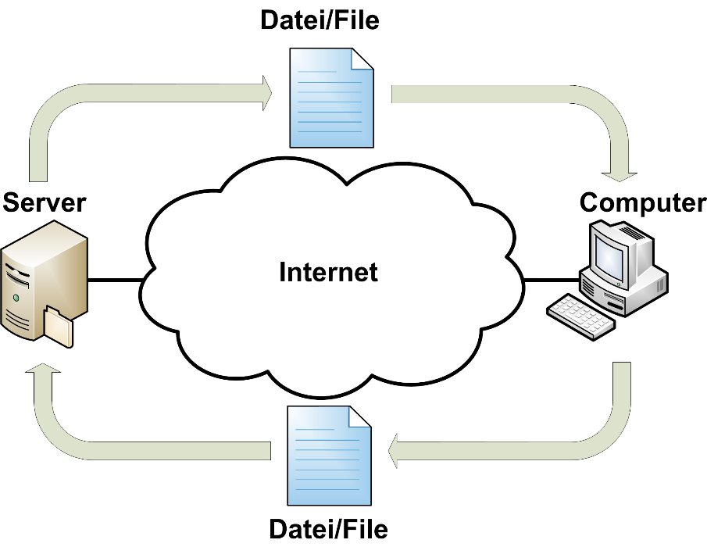

Figure 3.1: Target System in an Overview

## Use Cases for the Prototype

Investigated and prototypically implemented cases?

Example:

For a demonstration of the functionality, a prototype of the client software and a prototype of the server software has to be implemented.

* The prototype of the server software has the ability to connect with multiple clients.
* With the help of the client software a user can connect to the server using user name and password.
* …

The client software has a graphical interface with the functionality to:

* Log on to the server
* Log out of the server
* Stopping the Client software
* Manage multiple users
* Managing multiple server profiles for each user
* Selecting files on the local file system for upload or manipulation
* Selecting files on the server for download or manipulation
* Rename, delete and copy files on the local file system
* Rename, delete and copy files on the server
* Upload the selected files to the server
* Download the selected files from the server
* Cancel the upload and download process
* Selecting / creating the destination directory on the server
* Selecting / creating the destination directory on the client
* …

The server software with the Web Interface has the functionality to:

* Authenticating the user
* Establishing multiple connections simultaneously with the clients
* Manage multiple users with its files via the web interface
* Managing the directory structure of each user
* Web-based configuration of the server
* Secure transfer of files
* Repeat the file transfer on errors
* …

# Realisation / Implementation

In the chapter Realisation the „how“ is described, how the project is realised. The source code of the implemen-tation should not be printed into this chapter. It is possible to use and describe relevant code snippets and self-created flow diagrams, sequence diagrams or similar.

# Summary and Perspectives

New Ideas

To take the discussion further

Criticism of one´s own work

* Why it went wrong?

Example:

The developed prototype confirmed the concept of the software for exchanging files between server and client computers. File and user management on the server has been solved with a MySQL database. The server component has a web interface. With this web interface, the server administrator can configure the server, can manage files and can manage the authorized user. The client computer uses a graphical user interface that enables the user to log on to the server and upload and download files. To transfer the files between the computers, file transfer protocol (FTP) was used.

Multiple users can simultaneously log on to the server component. Each user only sees the files uploaded by him. Each user must be authenticated with his user name and password in order to get access to his files.

The architecture can be extended with an option for a simultaneous upload of multiple files in order to exploit the available bandwidth optimally. In order to exchange files also between server and smartphone, a corresponding smartphone app should be created as a supplement for the client component.

…

# Abbreviations

|  |  |
| --- | --- |
| **0** |  |
| … |  |
| **3** |  |
| 3GPP | Third Generation Partnership Project |
| … |  |
| **A** |  |
| … |  |
| **G** |  |
| GSM | Global System for Mobile communications |
| GUI | Graphical User Interface |
| GW | Gateway |
|  |  |
| **H** |  |
| HSS | Home Subscriber Server |
| HTML | Hypertext Mark-up Language |
| HTTP | Hypertext Transfer Protocol |
| **…** |  |
| **Z** |  |
| **…** |  |

A list of abbreviations contains only subject-specific abbreviations that are not listed in the Spelling Dictionary or are in general use.

The abbreviations are listed here in an invisible table without frames.

# References

1. Bahr, J. and Frackmann M. (2011): *Richtig zitieren nach der Harvard-Methode Eine Arbeitshilfe für das Verfassen wissenschaftlicher Arbeiten*, Solothurn (Schweiz): Institut für Praxisforschung, [online] http://www.institut-praxisforschung.com/app/download/6167762784/Harvard-Zitierweise.pdf [accessed 4 September 2015].
2. Pear, R. and Shields, G. (2008): *Cite Them Right: The Essential Referencing Guide,* Newcastle upon Tyne: Pear Tree Books.
3. Trick, U. and Weber, F. (2015): *SIP und Telekommunikationsnetze: Next Generation Networks und VoIP – konkret,* 5th ed., Berlin/Boston: De Gruyter Oldenbourg.
4. University of Plymouth (2011): *International Masters Programme (Education) Student Handbook March 2011*, Plymouth UK: University of Plymouth, [online] www6.plymouth.ac.uk/files/extranet/docs/FoE/Handbook March 2011 Final.pdf [accessed 1 July 2015].

# Appendix

Attached CD/DVD content